**Lab 1. Viết Dockerfile cho ứng dụng ReactJS**

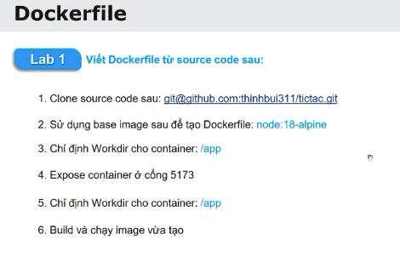

# 1/ Tải git về

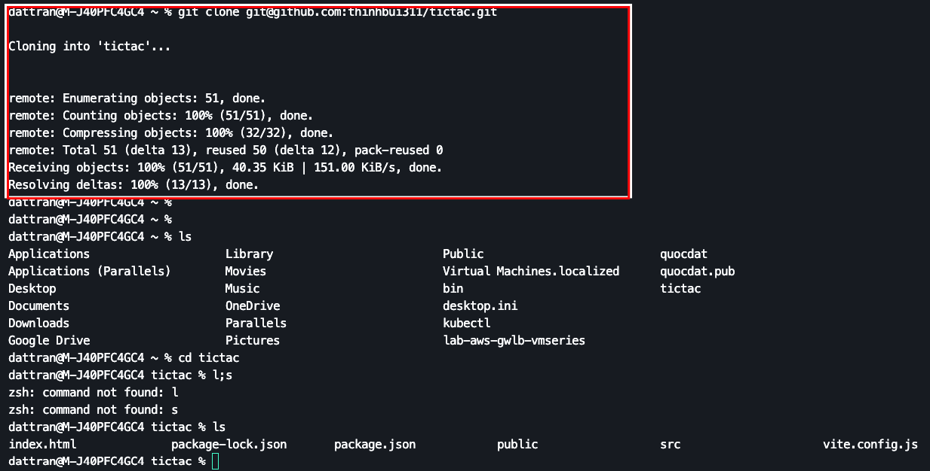

# 

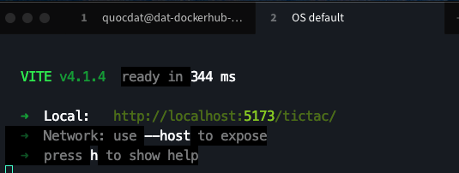

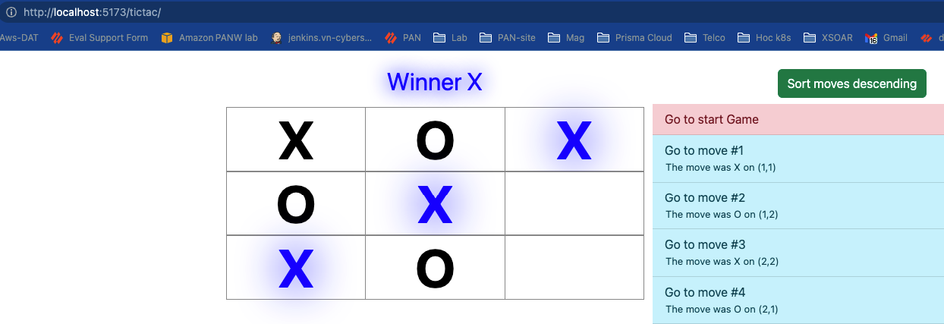

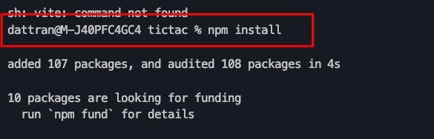

2/ Chạy với docker

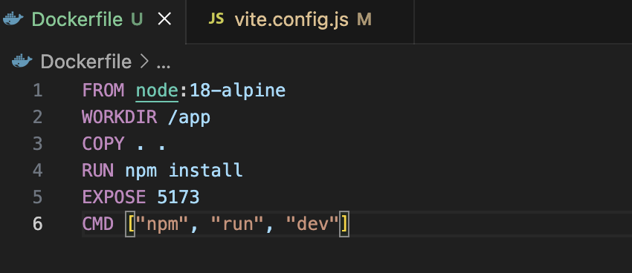

Docker build

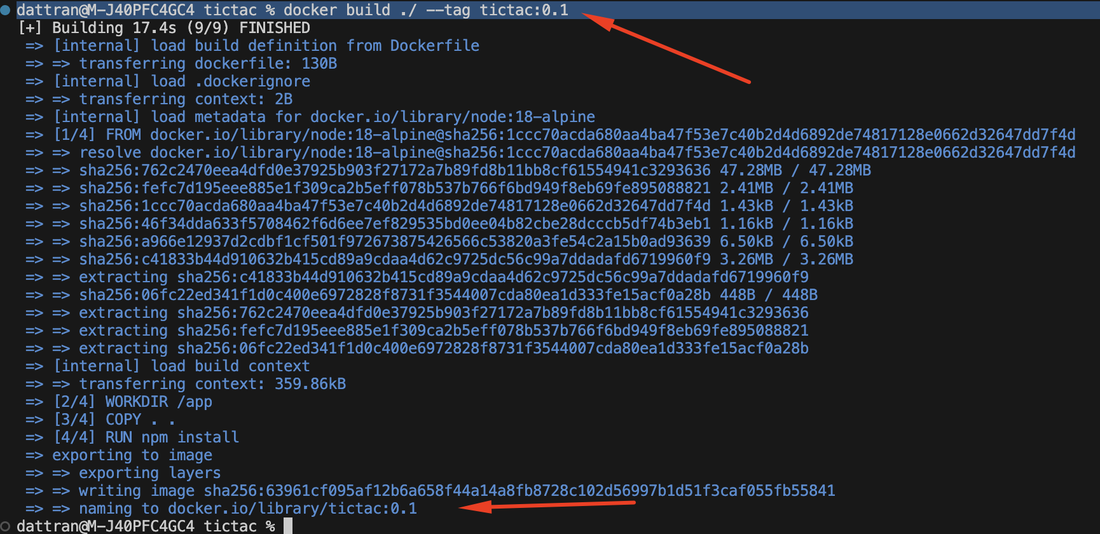

Danh sách image bao gồm cái vừa build

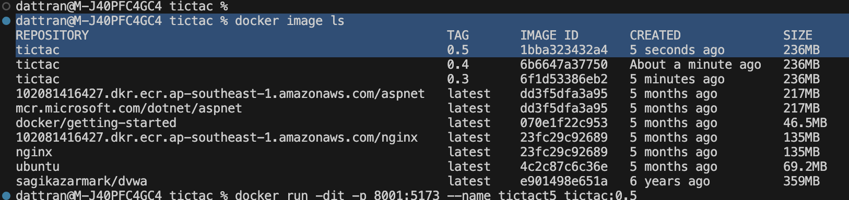

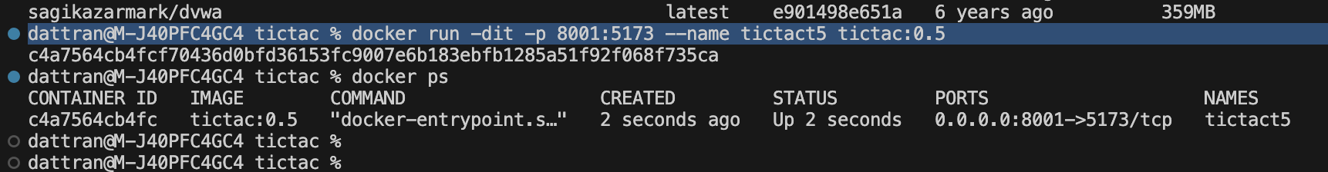

Chạy dịch vụ

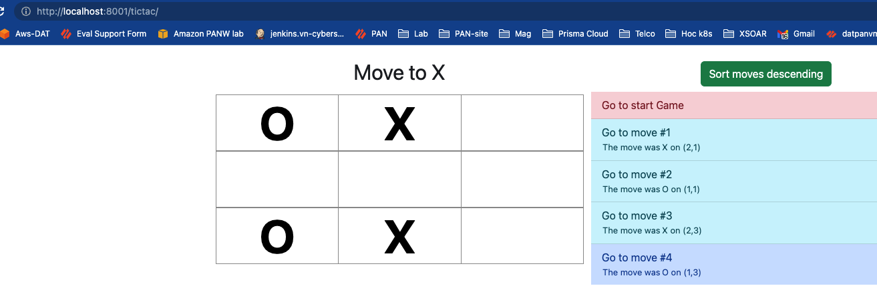

**Code trong container**

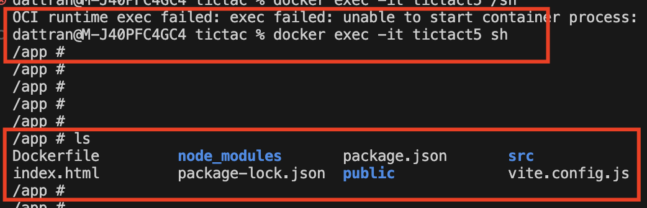

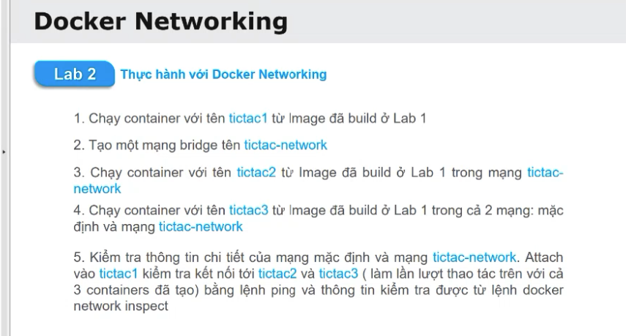

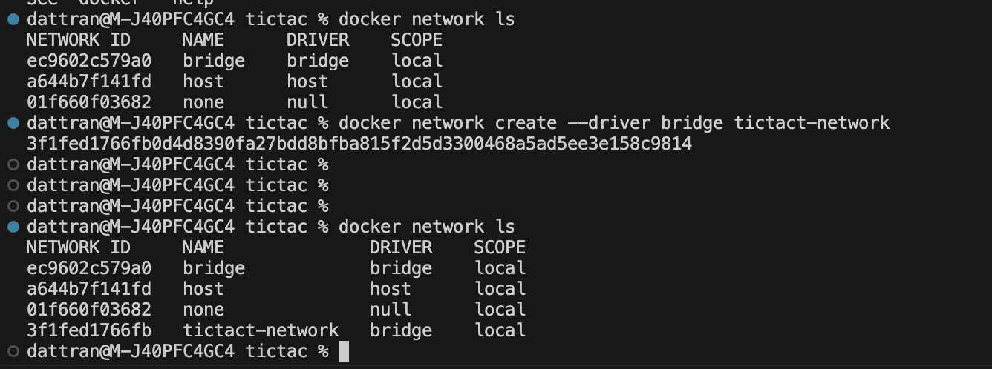

| See 'docker --help'  dattran@M-J40PFC4GC4 tictac % docker network ls  NETWORK ID NAME DRIVER SCOPE  ec9602c579a0 bridge bridge local  a644b7f141fd host host local  01f660f03682 none null local  dattran@M-J40PFC4GC4 tictac % docker network create --driver bridge tictact-network  3f1fed1766fb0d4d8390fa27bdd8bfba815f2d5d3300468a5ad5ee3e158c9814  dattran@M-J40PFC4GC4 tictac %  dattran@M-J40PFC4GC4 tictac %  dattran@M-J40PFC4GC4 tictac %  dattran@M-J40PFC4GC4 tictac % docker network ls  NETWORK ID NAME DRIVER SCOPE  ec9602c579a0 bridge bridge local  a644b7f141fd host host local  01f660f03682 none null local  3f1fed1766fb tictact-network bridge local  dattran@M-J40PFC4GC4 tictac % |
| --- |

*dattran@M-J40PFC4GC4 tictac % docker inspect bridge*

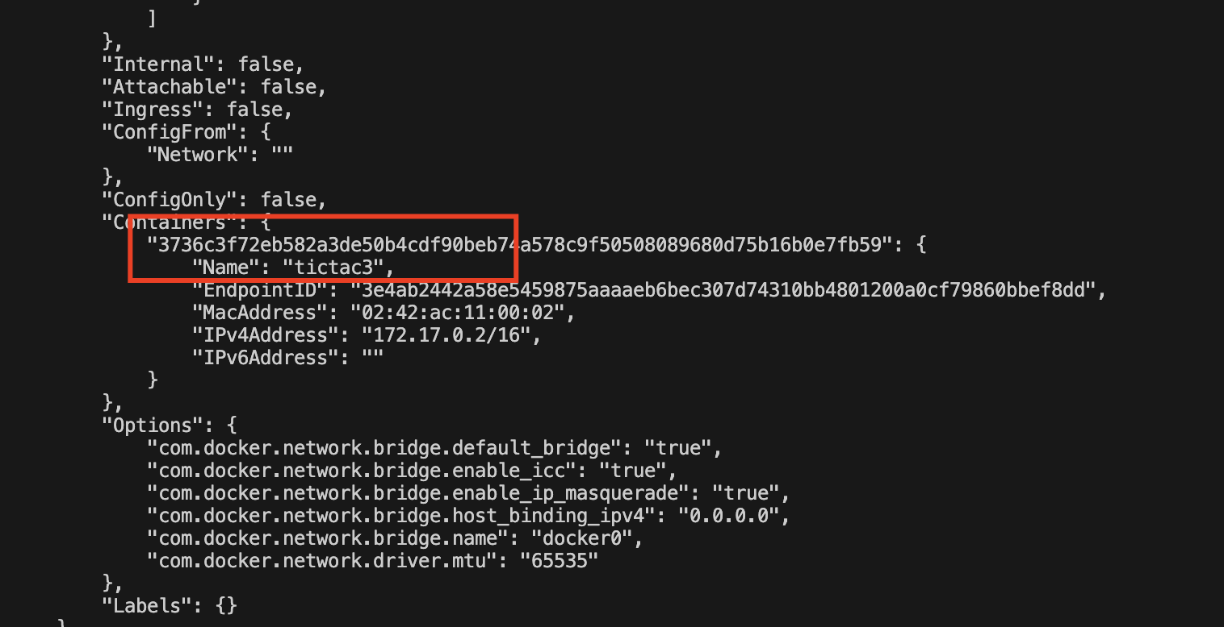

* **Chay container voi networks tictact vua moi tao**

docker run -dit --name tictact4 --network tictact-network tictac:0.5

\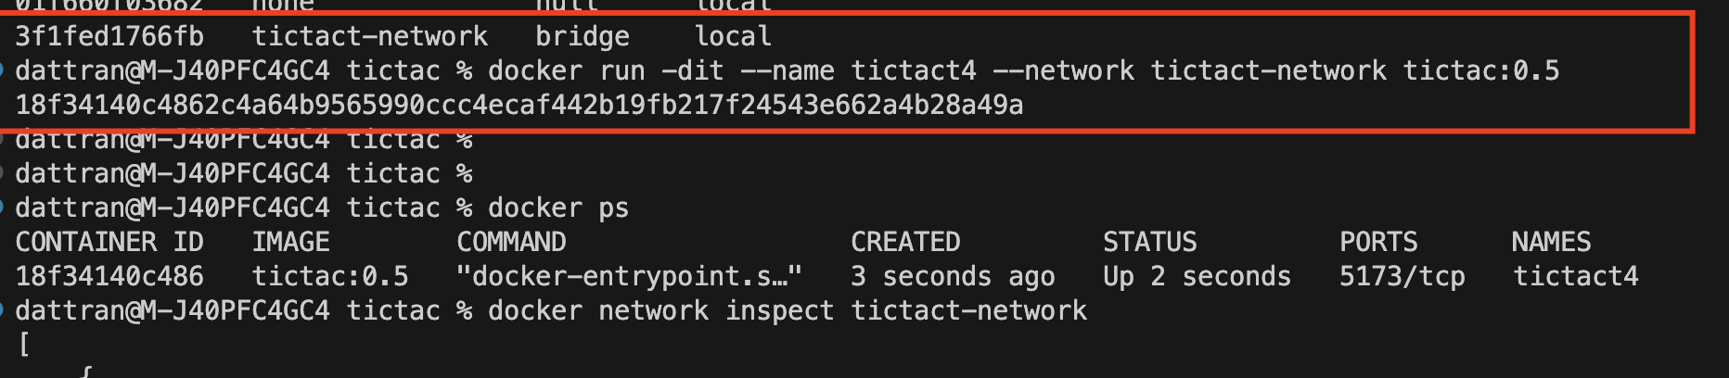

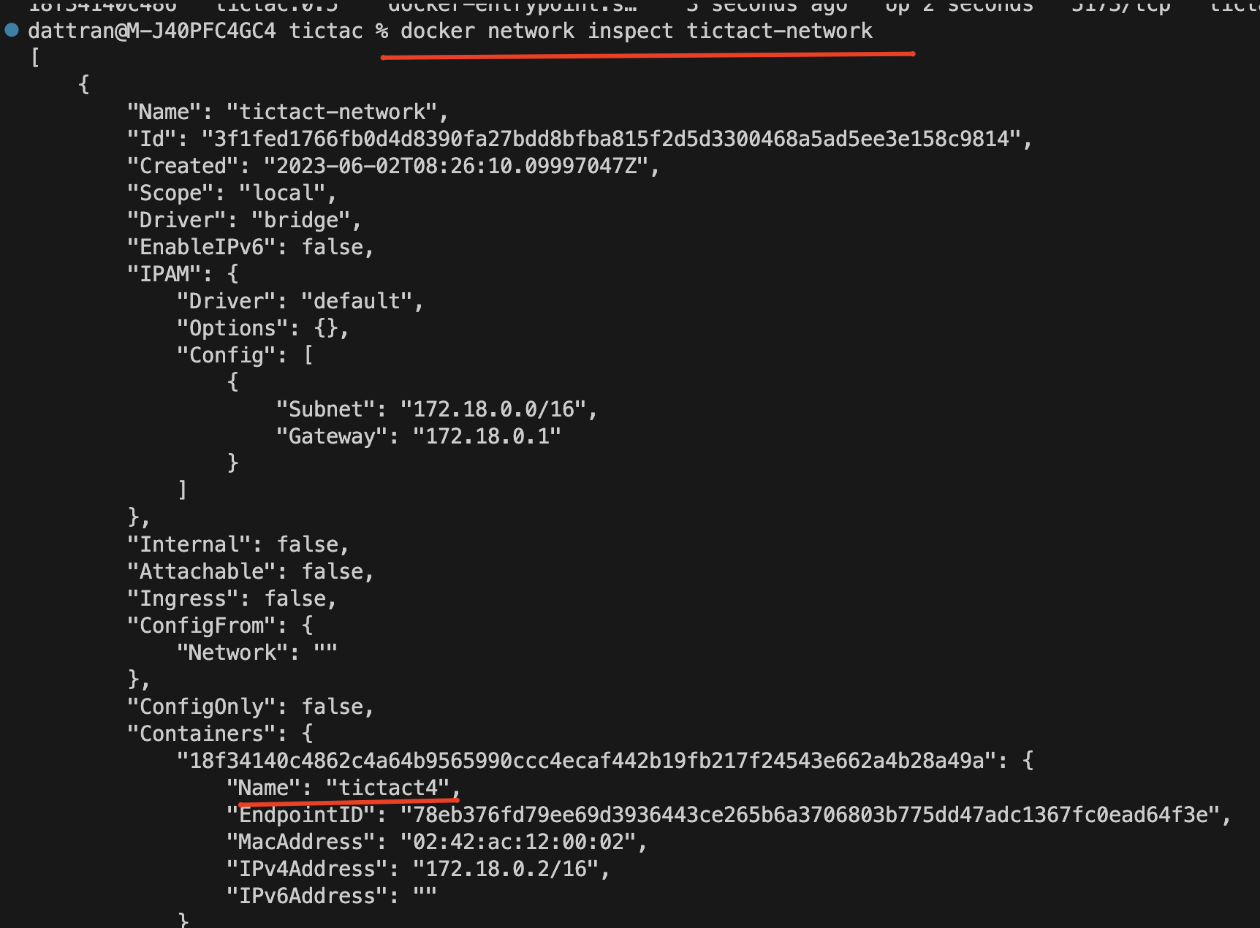

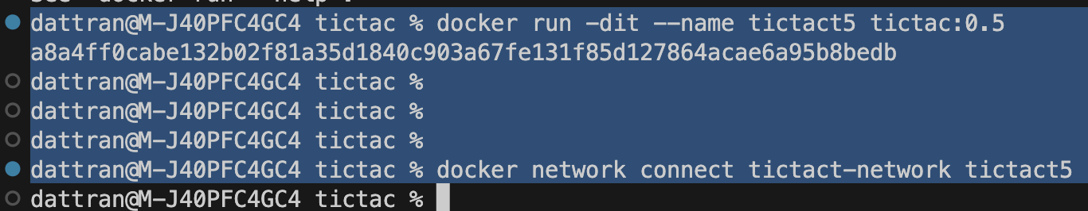

Ping giua cac container

